Keil Software

Installing the Keil software on a Windows PC

- Insert the CD-ROM in your computer’s CD drive
- On most computers, the CD will “auto run”, and you will see the Keil installation menu. If the menu does not appear, manually double click on the Setup icon, in the root directory: you will then see the Keil menu.
- On the Keil menu, please select “Install Evaluation Software”. (You will not require a license number to install this software).
- Follow the installation instructions as they appear.

Loading the Projects

The example projects for this book are NOT loaded automatically when you install the Keil compiler.
These files are stored on the CD in a directory “/Pont”. The files are arranged by chapter: for example, the project discussed in Chapter 3 is in the directory “/Pont/Ch03_00-Hello”.
Rather than using the projects on the CD (where changes cannot be saved), please copy the files from CD onto an appropriate directory on your hard disk.
Note: you will need to change the file properties after copying: file transferred from the CD will be ‘read only’.

Configuring the Simulator

Open the Keil μVision2

Go to Project – Open Project and browse for Hello in Ch03_00 in Pont and open it.
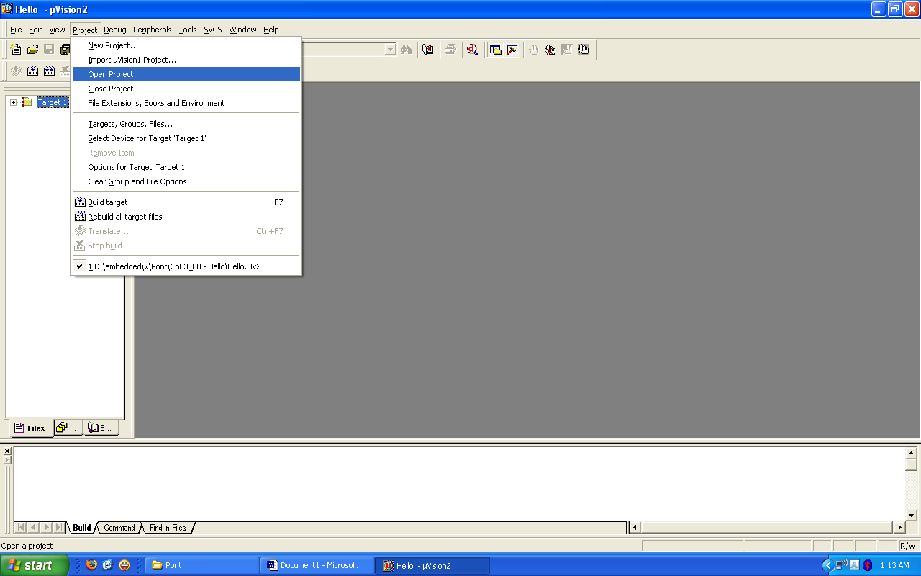

Go to Project – Select Device for Target ‘Target1’
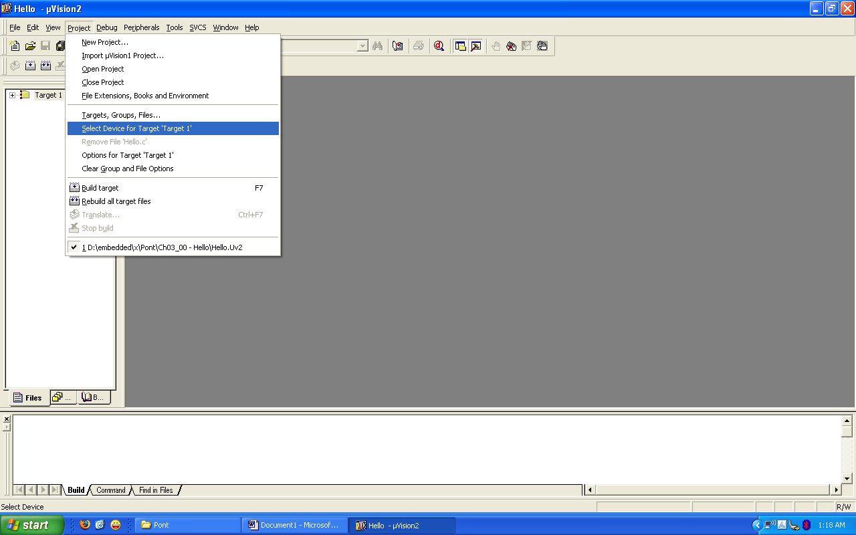

Select 8052(all variants) and click OK

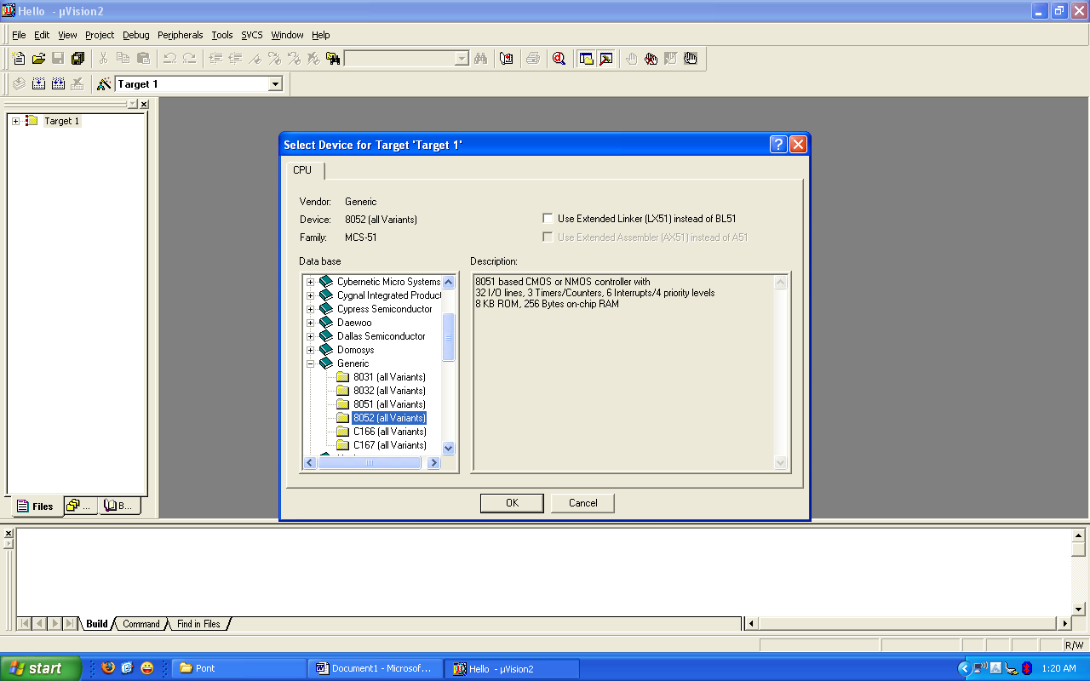

Now we need to check the oscillator frequency:
Go to project – Options for Target ‘Target1’
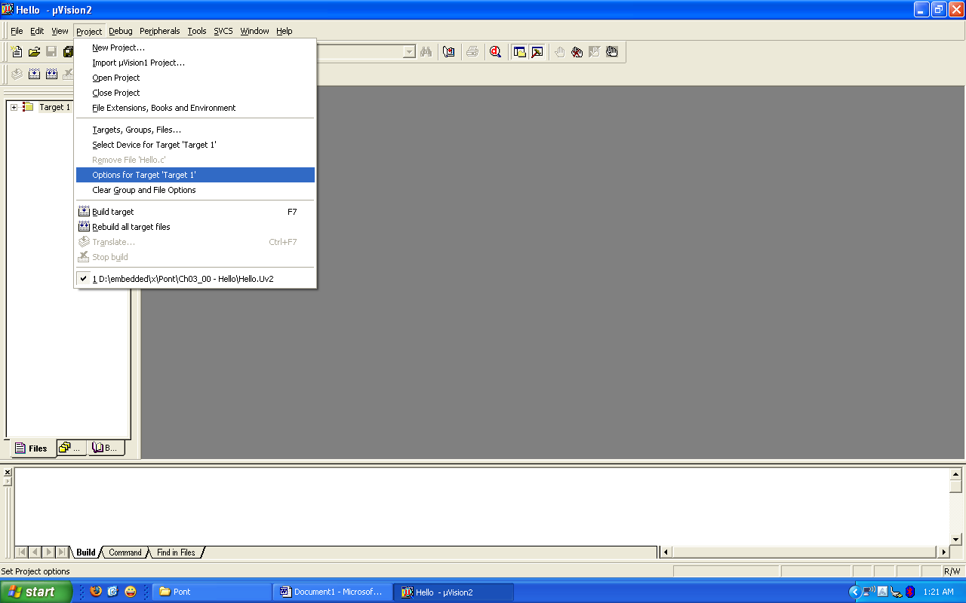

Make sure that the oscillator frequency is 12MHz.
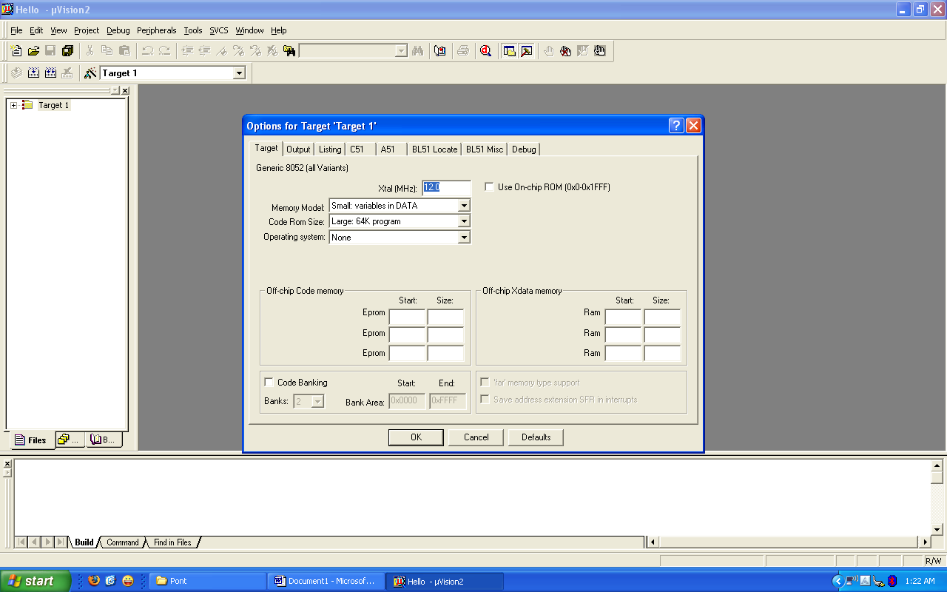

Building the Target

Build the target as illustrated in the figure below
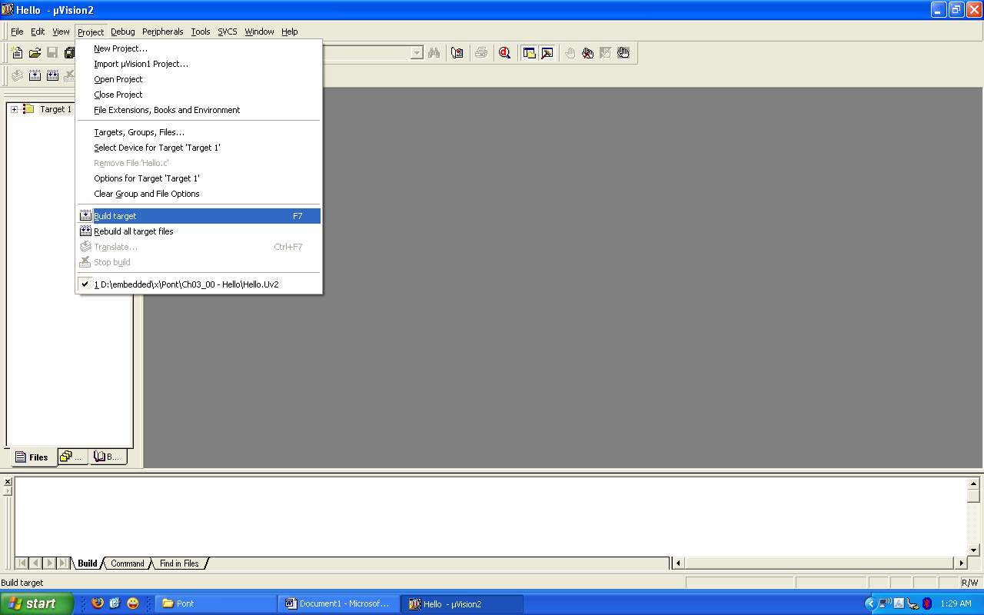

Running the Simulation
Having successfully built the target, we are now ready to start the debug session and run the simulator.
First start a debug session
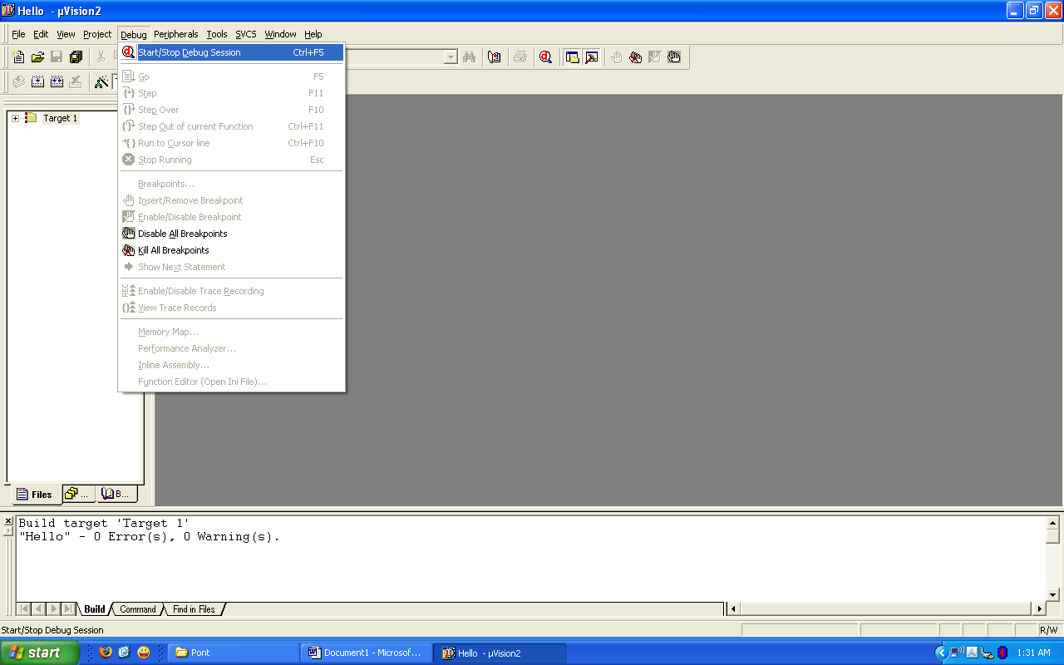

The flashing LED we will view will be connected to Port 1. We therefore want to observe the activity on this port
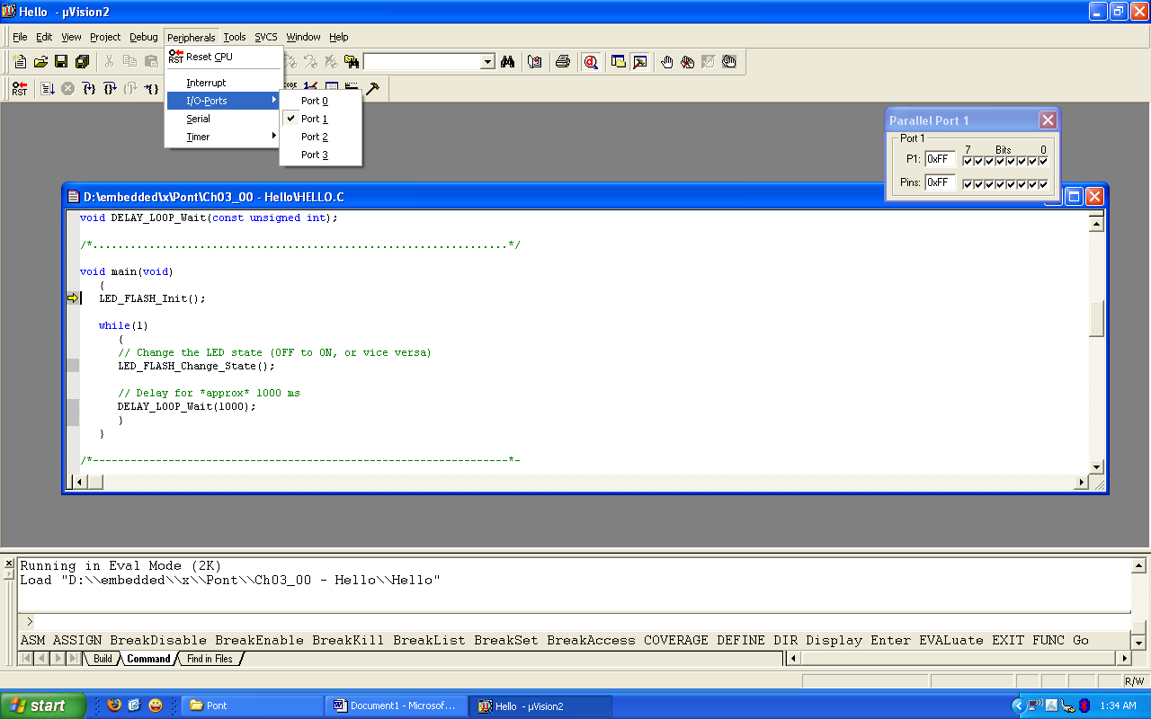
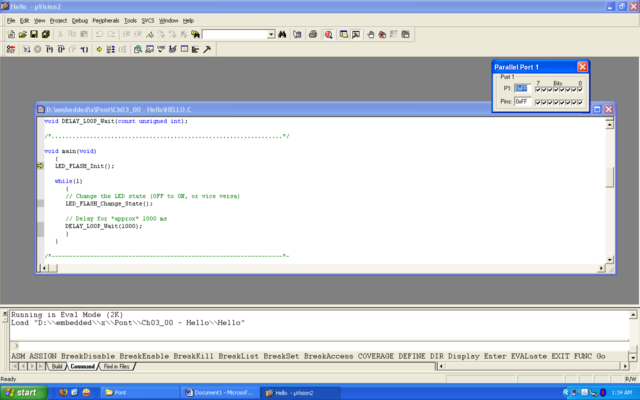

To ensure that the port activity is visible, we need to start the ‘periodic window update’ flag
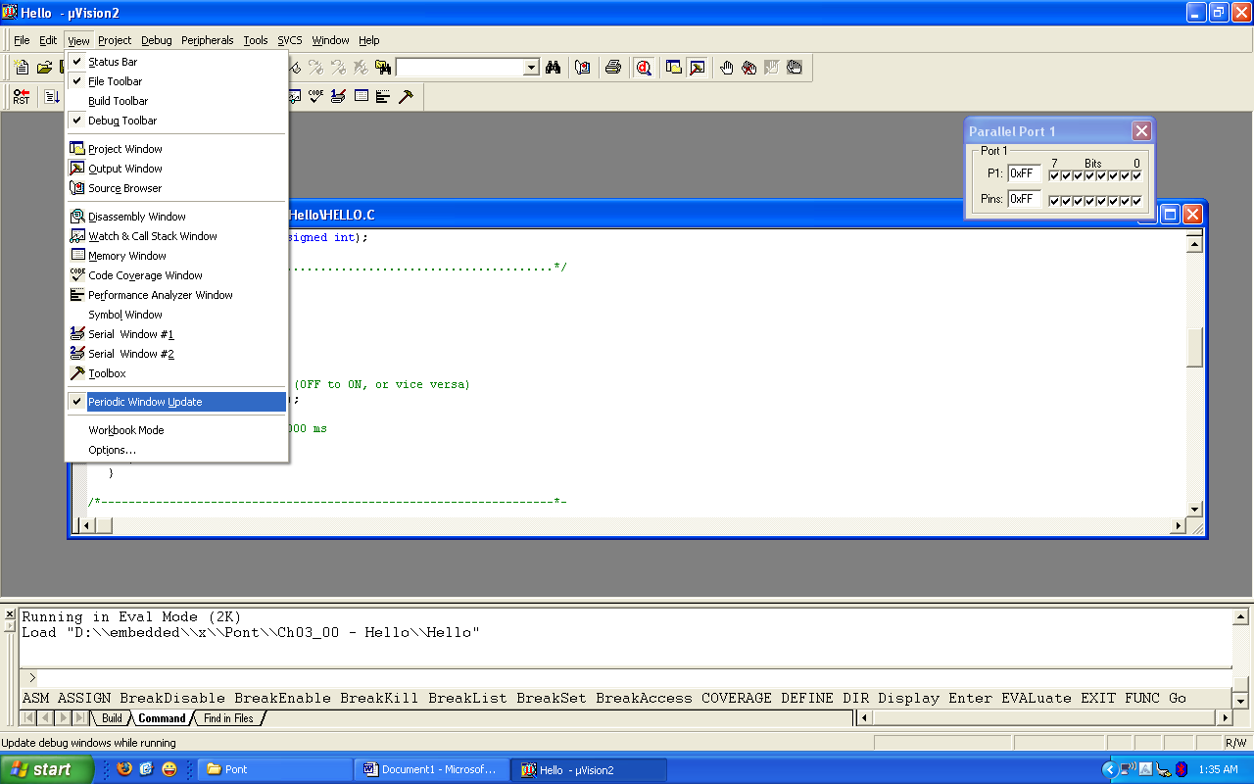

Go to Debug - Go
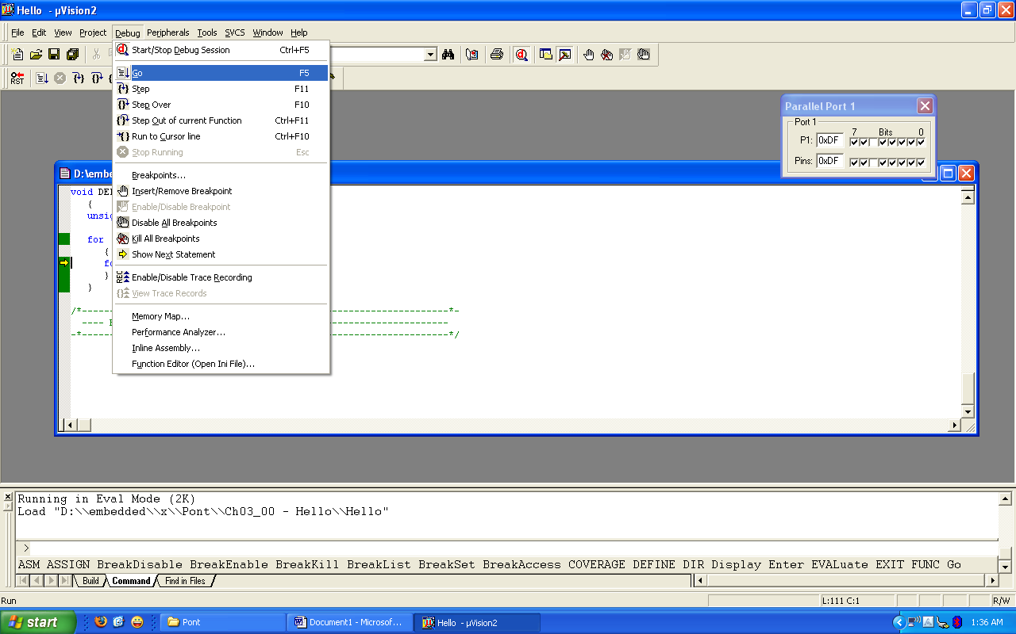

While the simulation is running, view the performance analyzer to check the delay durations.
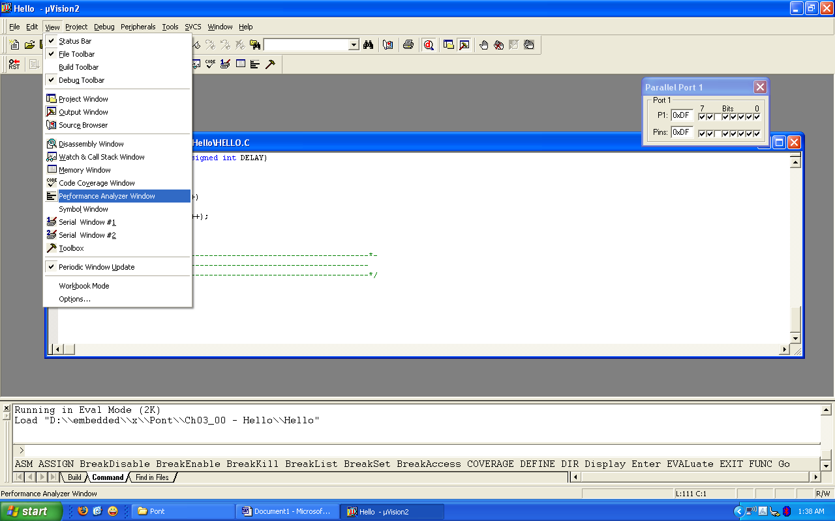

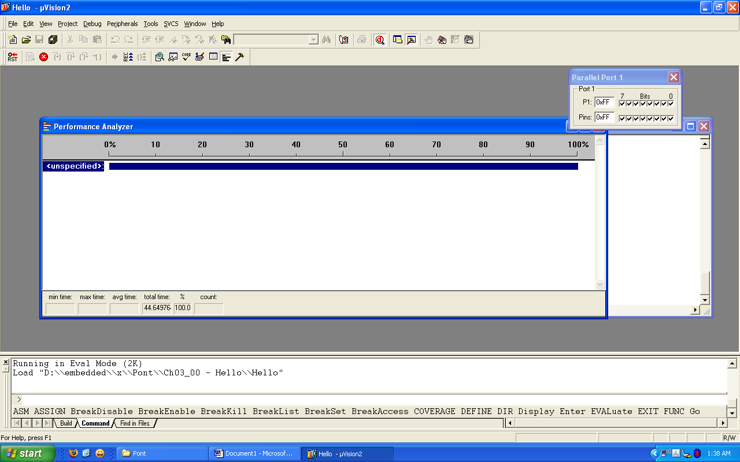

Go to Debug – Performance Analyzer and click on it

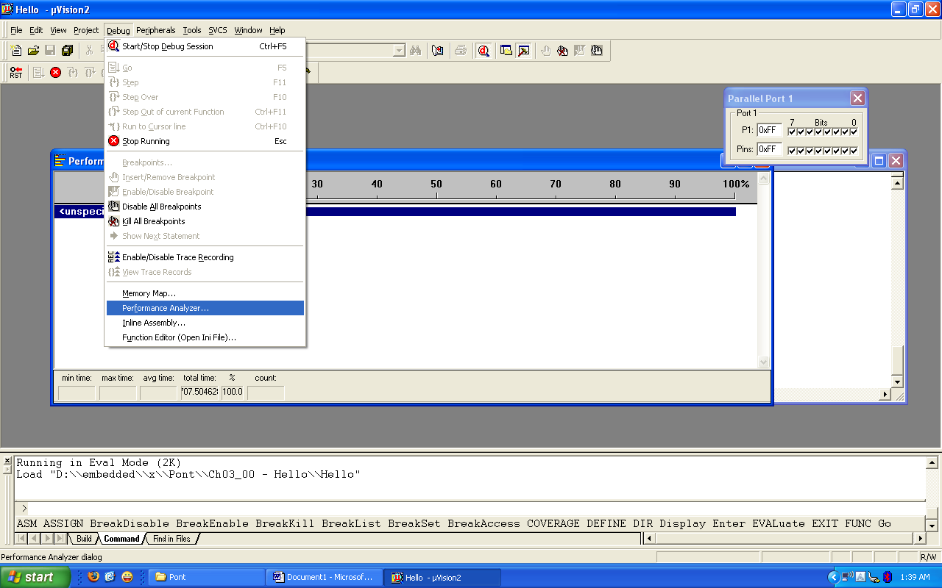

Double click on DELAY_LOOP_Wait in Function Symbols: and click Define button

